

**SLMS**

**S**tudent **L**eave **M**anagement **S**ystem

# Purpose of this application

The purpose of this application is to allow students request the leave.

For instance, students are sick, family event, brother or sister marry…

Submit a leave request

* New request
* Leave type: Sick leave, Family Event, Brother & Sister Marry …
* Start Date – End Date
* Duration
* Cause (reason)
* Requested or Cancel

**Use case Diagram:**

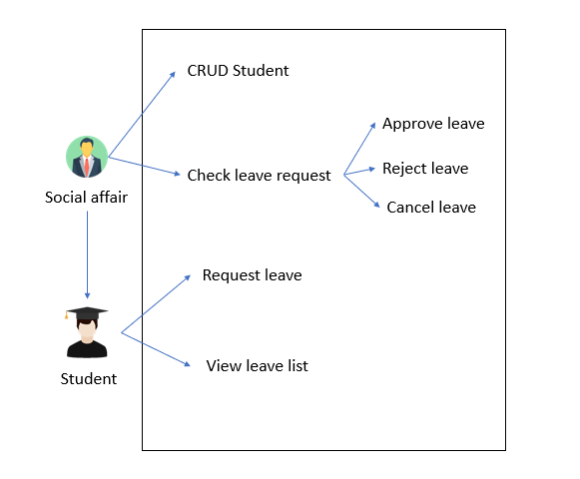

# Planning

**The project must respect the deadlines and must be finished within in 2 weeks**

|  |  |
| --- | --- |
| **ITERATION** | **FEATURE** |
| WEEK1 | Menu Bar |
| New Request |
| List all leaves |
| WEEK2 | Authentication (Login both user account ADMIN & STUDENT) |
| CRUD Students [Admin] |
| Check Leave |

# TASK 1 – Menu Bar

Suggestion of sub tasks

|  |  |  |
| --- | --- | --- |
| **TASK** | **LABEL** | **DETAIL** |
| Mock Up | **[document]** | Draw the mock-up of your project |
| Update CD | **[document]** | Update the component diagram for frontend |
| Create menu-bar | **[front-component]** | * The logged user shall be displayed on the menu bar * The 3-menu item hall link to 3 empty views (component) * A Logout menu item on the right side   + When logout the user id is removed from local storage |

**Menu for student’s role:**

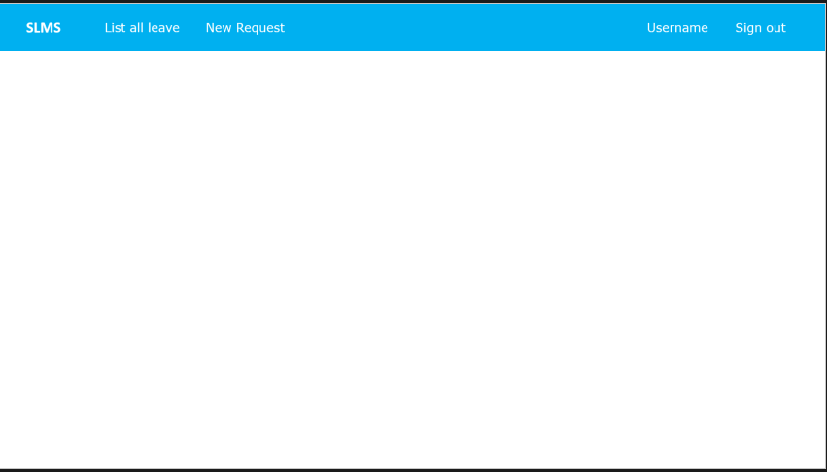

**Menu for Social affair’s role:**



# TASK 2 – New Request

When the student clicks on New Request it shall display the form to input some data such as:

* Leave type
* Start date (Morning or Afternoon)
* End date (Morning or Afternoon)
* Duration of leave (Count the day start from start-date to end-date)
* Reason of leave (cause)

After user click on submit all those data need to send to back-end and store in database.

Note: all fields are required except Reason(cause).

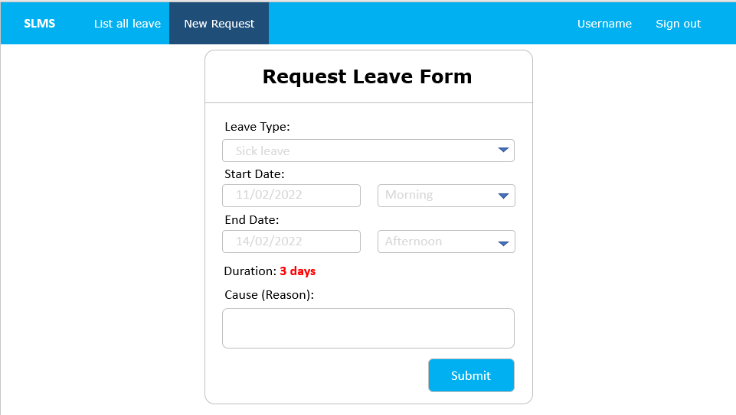

|  |  |  |
| --- | --- | --- |
| **TASK** | **LABEL** | **DETAIL** |
| Mock Up | **[document]** | Draw the mock-up of your project |
| Update ERD | **[document]** | Update the ERD document of your database |
| Update Route | **[document]** | Update the route document backend/frontend |
| Update CD | **[document]** | Update the component diagram for frontend |
| Create leave request | **[back-end]** | * Manage: route / controller / model /migration * Create request leave * Validation on information required   … |
| Create request leave form | **[front-component]** | Create form to request leave following the fields needed above. |

# TASK 3 – List all Leaves

1. **List all the leaves**

After the student create leave they can view their leave request by click on **List all Leaves**. It shall display all the information that have in input fields and include with **date of the request** created.

In the list have status of the request there are four status:

* **Padding**: mean social affaire didn’t check the leave yet (by default after request leave).
* **Approved**: mean social affaire is allowed you to leave.
* **Cancelled**: mean student already request leave and he/she doesn’t want to leave so they can request to social affaire to cancel leave.
* **Rejected**: mean social didn’t allow student to leave.

1. **Filter the leave**

* Filter by Leave types
* Filter by status

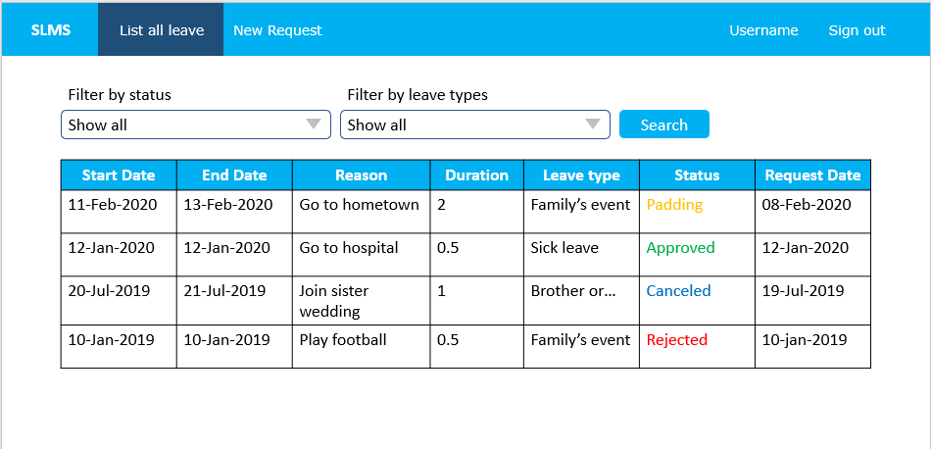

|  |  |  |
| --- | --- | --- |
| **TASK** | **LABEL** | **DETAIL** |
| Mock Up | **[document]** | Draw the mock-up of your project |
| Update ERD | **[document]** | Update the ERD document of your database |
| Update Route | **[document]** | Update the route document backend/frontend |
| Update CD | **[document]** | Update the component diagram for frontend |
| List all the requests | **[back-end]** | * Manage: route / controller / model /migration * list all leave requests * Calculate the duration of leave.   … |
| Create **list all requests** **view** | **[front-component]** | Display the view following the example above. |

# TASK 4 – Authentication

We have two roles in the system one is Social affair one is the student. We need a login form with:

* Email (need to be strict only passerellesnumber’s email)
* Password (must more than 8 characters)

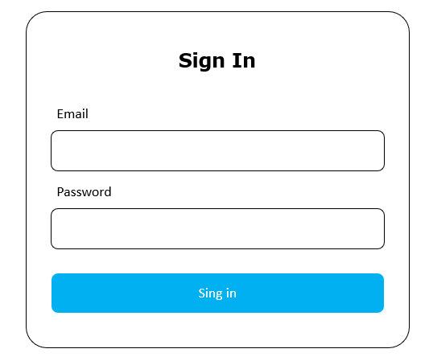

1. If user login as social affair role shows this menu:



1. If user login as the student role shows this menu:



|  |  |  |
| --- | --- | --- |
| **TASK** | **LABEL** | **DETAIL** |
| Mock Up | **[document]** | Draw the mock-up of your project |
| Update ERD | **[document]** | Update the ERD document of your database |
| Update Route | **[document]** | Update the route document backend/frontend |
| Update CD | **[document]** | Update the component diagram for frontend |
| Create form login | **[front-end]** | Create a component with two input fields   * Email * Password |
| User login | **[back-end]** | * Manage: route / controller / model /migration * Create request leave * Validation on information required   … |

# TASK 5 – CRUD Student

Social affair is able to manage on the student such as:

1. Add student
2. Edit student
3. Delete student
4. View all student
5. View the student detail

# TASK 6 – Approve Leave